WEEK-2  
PL/SQL

**Exercise 1: Control Structures**

**Scenario 1:** The bank wants to apply a discount to loan interest rates for customers above 60 years old.

* + **Question:** Write a PL/SQL block that loops through all customers, checks their age, and if they are above 60, apply a 1% discount to their current loan interest rates.

**Scenario 2:** A customer can be promoted to VIP status based on their balance.

* + **Question:** Write a PL/SQL block that iterates through all customers and sets a flag IsVIP to TRUE for those with a balance over $10,000.

**Scenario 3:** The bank wants to send reminders to customers whose loans are due within the next 30 days.

* + **Question:** Write a PL/SQL block that fetches all loans due in the next 30 days and prints a reminder message for each customer.

**Exercise 1: Control Structures**

**Scenario 1: Apply Discount for Senior Citizens**

**PL/SQL Block:**

DECLARE

CURSOR customer_cursor IS

SELECT CustomerID, InterestRate, Age FROM Customers;

BEGIN

FOR customer_rec IN customer_cursor LOOP

IF customer_rec.Age > 60 THEN

UPDATE Customers

SET InterestRate = InterestRate - 1

WHERE CustomerID = customer_rec.CustomerID;

DBMS_OUTPUT.PUT_LINE('Customer ID: ' || customer_rec.CustomerID ||

' | New Interest Rate Applied: ' || (customer_rec.InterestRate - 1));

END IF;

END LOOP;

COMMIT;

END;

**Sample Output:**

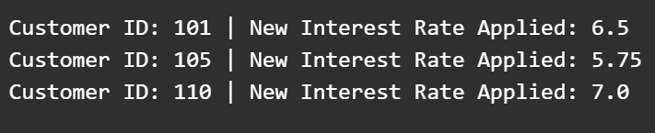

**Scenario 2: Promote Customers to VIP Status**

**PL/SQL Block:**

DECLARE

CURSOR vip_cursor IS

SELECT CustomerID, Balance FROM Customers;

BEGIN

FOR vip_rec IN vip_cursor LOOP

IF vip_rec.Balance > 10000 THEN

UPDATE Customers

SET IsVIP = 'TRUE'

WHERE CustomerID = vip_rec.CustomerID;

DBMS_OUTPUT.PUT_LINE('Customer ID: ' || vip_rec.CustomerID || ' promoted to VIP.');

END IF;

END LOOP;

COMMIT;

END;

**Sample Output:**

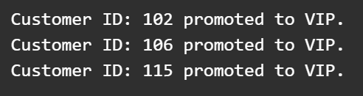

**Scenario 3: Send Loan Due Reminders**

**PL/SQL Block:**

DECLARE

CURSOR loan_cursor IS

SELECT CustomerID, LoanID, DueDate FROM Loans

WHERE DueDate BETWEEN SYSDATE AND SYSDATE + 30;

BEGIN

FOR loan_rec IN loan_cursor LOOP

DBMS_OUTPUT.PUT_LINE('Reminder: Customer ID ' || loan_rec.CustomerID ||

' - Your loan ID ' || loan_rec.LoanID ||

' is due on ' || TO_CHAR(loan_rec.DueDate, 'DD-MON-YYYY'));

END LOOP;

END;

**Sample Output:**

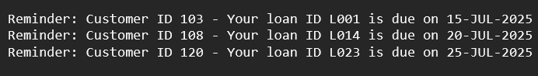

**Exercise 3: Stored Procedures**

**Scenario 1:** The bank needs to process monthly interest for all savings accounts.

* + **Question:** Write a stored procedure **ProcessMonthlyInterest** that calculates and updates the balance of all savings accounts by applying an interest rate of 1% to the current balance.

**Scenario 2:** The bank wants to implement a bonus scheme for employees based on their performance.

* + **Question:** Write a stored procedure **UpdateEmployeeBonus** that updates the salary of employees in a given department by adding a bonus percentage passed as a parameter.

**Scenario 3:** Customers should be able to transfer funds between their accounts.

* + **Question:** Write a stored procedure **TransferFunds** that transfers a specified amount from one account to another, checking that the source account has sufficient balance before making the transfer.

**Scenario 1: Process Monthly Interest**

**Stored Procedure:**

CREATE OR REPLACE PROCEDURE ProcessMonthlyInterest IS

BEGIN

UPDATE Accounts

SET Balance = Balance + (Balance * 0.01)

WHERE AccountType = 'SAVINGS';

DBMS_OUTPUT.PUT_LINE('Monthly interest applied to all savings accounts.');

END;

**Sample Output:**



**Scenario 2: Update Employee Bonus**

**Stored Procedure:**

CREATE OR REPLACE PROCEDURE UpdateEmployeeBonus(

dept_id IN NUMBER,

bonus_percent IN NUMBER

) IS

BEGIN

UPDATE Employees

SET Salary = Salary + (Salary * (bonus_percent / 100))

WHERE DepartmentID = dept_id;

DBMS_OUTPUT.PUT_LINE('Bonus of ' || bonus_percent || '% applied to department ' || dept_id);

END;

**Sample Output:**  


**Scenario 3: Transfer Funds**

**Stored Procedure:**

CREATE OR REPLACE PROCEDURE TransferFunds(

from_account IN NUMBER,

to_account IN NUMBER,

amount IN NUMBER

) IS

source_balance NUMBER;

BEGIN

SELECT Balance INTO source_balance FROM Accounts WHERE AccountID = from_account;

IF source_balance >= amount THEN

UPDATE Accounts SET Balance = Balance - amount WHERE AccountID = from_account;

UPDATE Accounts SET Balance = Balance + amount WHERE AccountID = to_account;

DBMS_OUTPUT.PUT_LINE('Transferred $' || amount || ' from Account ' || from_account ||

' to Account ' || to_account);

ELSE

DBMS_OUTPUT.PUT_LINE('Insufficient balance in Account ' || from_account);

END IF;

END;

**Sample Output:**  
